**AYSO AREA 8/A HALLOWEEN CLASSIC**

**October 18th -19th2024**

**Tournament Information**

**Dates:**  October 18-19, 2024

**Location:** Grant, Michigan

**Registration Date:** Entries must be received by September 29, 2024

**Registration Fee:** Per Player fee (Regardless of division)- the amount paid to the host region is

$27.25. $30.00 minus the 2.75 processing fee for a total of $27.25.

**Paperwork:** Team Application and Team Roster - Submitted and accepted online

Referee Form - Submitted via email.

T-Shirt Pre-Order - Must be submitted by September 29, 2024

Player Waiver forms, AYSO ID, and AYSO Roster will be required at check-in

**Board Representation:** Each region must have board representation at the tournament.

**Referee:** Each region is encouraged to supply at least 4 referees. Referee support from

each region is essential to the success of this tournament.

**Payments:** Payments to: **AYSO 1472 -Grant AYSO Area 8A Tournament**

Checks must be drawn on an AYSO Regional account.

**Who Can Register:** AYSO-Area 8/A house teams. Player must have played on a house team during

the regular season.The only exception will apply to the 19u Boys division. Those

players must be approved by the tournament board. All players must be from the

same region. regular season roster, signed by your Regional Commissioner. All players must be from the same Region. Teams from other Areas may be accepted to fill brackets.

**Format:** Round-Robin type format with Semi-Final and Championship games for divisions

with more than one bracket.

**Divisions:** 10U Boys and Girls, 5 players on roster.

12U Boys and Girls, 5 players on roster.

14U Coed, 5 players on roster

19U Coed, 5 players on roster

**Age Cut off Date:** The cut-off date for each division will be the same as AYSO for the season

immediately preceding the tournament.

**Minimum Games:** Each team will play a minimum of three games. All games will be 20 minutes

with one break for half for substitutions.

**Awards:**  Awards will be given to the top four teams from each division. There will also be

awards for the best costume for each division.

**Contact**: Dannielle Leber 616-308-2542 or RC@grantayso.org

Dawn Ausema 231-343-5956 or [dawnausema@hotmail.com](mailto:dawnausema@hotmail.com)

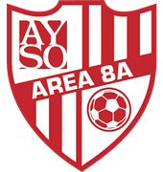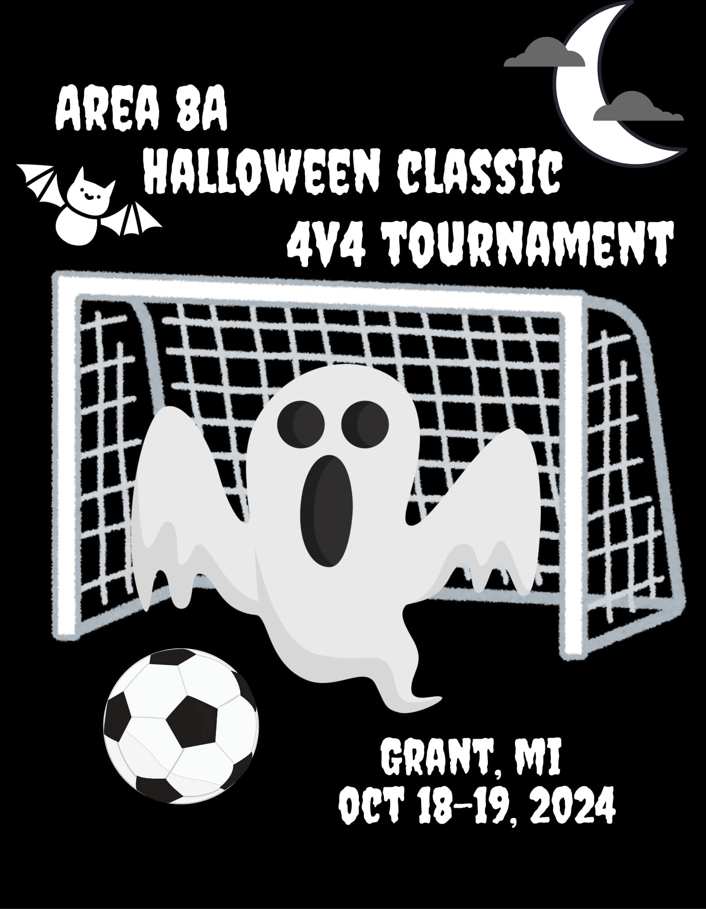

**AYSO AREA 8/A HALLOWEEN CLASSIC**

**October 17th - 19th2024**

**Tournament Wear Pre Order Form**

Tournament shirts will have the participating team

names and home regions listed on the back. We will have **Long Sleeve t-shirts and Hoodies by PRE ORDER ONLY**. There will be a minimal amount of T-shirts available during the tournament for $15. **PRE ORDERS must be received by September 29, 2024.**

|  |  |  |  |  |  |  |  |
| --- | --- | --- | --- | --- | --- | --- | --- |
|  |  |  | PRE-ORDER ONLY | | PRE-ORDER ONLY | |  |
|  | **Short Sleeve T-Shirt** | | **Long-Sleeve T-Shirt** | | **Hooded Sweatshirt** | |  |
|  | **Quantity** | **Price- $15** | **Quantity** | **Price- $20** | **Quantity** | **Price- $30** | **Totals** |
| **Youth Sizes** |  |  |  |  |  |  |  |
| **YXS** |  |  |  |  |  |  |  |
| **YS** |  |  |  |  |  |  |  |
| **YM** |  |  |  |  |  |  |  |
| **YL** |  |  |  |  |  |  |  |
| **YXL** |  |  |  |  |  |  |  |
| **Adult Sizes** |  |  |  |  |  |  |  |
| **S** |  |  |  |  |  |  |  |
| **M** |  |  |  |  |  |  |  |
| **L** |  |  |  |  |  |  |  |
| **XL** |  |  |  |  |  |  |  |
| **Plus Sizes- add $2** |  |  |  |  |  |  |  |
| **2XL (+ $2)** |  |  |  |  |  |  |  |
| **3XL (+ $2)** |  |  |  |  |  |  |  |
| **4XL (+ $2)** |  |  |  |  |  |  |  |
| **5XL (+ $2)** |  |  |  |  |  |  |  |
| **Totals** |  |  |  |  |  |  |  |

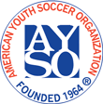

**AYSO AREA 8/A HALLOWEEN CLASSIC**

**October 17th - 19th2024**

**Referee Information Sheet**

**Referee Information Sheet and Tournament Referee Application Form**

**Personal Information:**

**Name:** _______________________________________ **Region:** ________ **Age (if under 19):** ____

**Address:** ________________________________________________________________________________ **City:** _________________________________ **State:** ____ **Zip:** _______ **Phone:** ____________ **Email:** __________________________________

**Shirt Size:** ______ **OR**

**Tournament Coin**: yes no (circle one)

**Ability Information:**

**Current Referee Grade:**  .

☐ Regional ☐ Intermediate ☐ Advanced ☐ National

**Comfort level:**

Center Referee: ☐ 10U ☐ 12U ☐ 14U ☐ 19U

Assistant Referee: ☐ 10U ☐ 12U ☐ 14U ☐ 19U

**Availability Information:**

☐ Saturday ☐ All Day ☐ Specific Times: ___________________________________________

☐ Sunday ☐ All Day ☐ Specific Times: ___________________________________________

I am bringing a referee team from my region. Please schedule me with the following referees:

_____________________________________ ___________________________________

**Assessments:**

Assessments should only be requested after completing the in person training for the requested level.

☐ Intermediate observation

☐ Assessment for Advanced: ☐ Center ☐ AR

**Conflicts:**

I coach, have children on, or have conflicts with the following teams:

Coach Name Team Name Player Name Age Level

_____________________ _____________________ __________________ ________

_____________________ _____________________ __________________ ________

## **AYSO Area 8/A Halloween Classic 4v4 Tournament Official Tournament Rules**

1. Unless denoted in this document, current FIFA rules apply. They can be found at the FIFA website, under Laws of the Game.
2. Each player will be required to have their signed medical release form. If the player is under 18, their parent or legal guardian will be required to sign the medical release form. By signing the medical release form you acknowledge that AYSO and the tournament committee is not responsible for lost or stolen property or any injury that may occur during the tournament. Proof of age of each player is required. (If any player’s age is challenged, that player will be required to present proof of date of birth to the tournament officials. Failure to provide proof will result in forfeit of the game.)
3. Only AYSO Area 8/A players may register. Each player must have played on a house team during the regular MY season. All players must be from the same Region, and the roster must be signed by the team’s Regional Commissioner. Players must be at least 10U division with no 8U players; even if the 8U player played up for the MY season. Teams from other AYSO Areas may be accepted to fill brackets if need be.
4. Teams will consist of not more than five (5) players and not less than three (3). A maximum of four (4) players and not less than three (3) players will be allowed on the field of play for each team. Substitutions may be made only when play is stopped and after notification is made to the referee. Substitutions may not be made on stoppage resulting from a foul or corner kick.
5. There are **NO GOALKEEPERS** allowed.
6. All players must wear approved shin guards and matching team jerseys or shirts. Costumes are allowed, you can wear themed costumes ie all superheroes. Costumes worn during a game should not pose a danger or prohibit play.
7. Playing fields will be 40 yards long and 25 yards wide. Goals will be approximately four (4) feet high by six (6) feet wide.
8. Players, Team Volunteers, and spectators will not be permitted to sit on the same side of the playing field. Players and the Team Volunteer of both teams will be on one side, while the spectators of both teams will be on the opposite side.
9. Games will consist of two (2) ten (10) minutes halves with a three (3) minute half time.
10. **There is no offside**.
11. All kicks made from the defensive half of the field are considered to be indirect. A goal can only be scored if the ball is last touched by a player from either team in the attacking half of the field of the team scoring the goal. A team **will not** be awarded a goal on a direct kick made on a kick-off or a kick-in from the sideline. A goal can be scored directly on a corner kick.
12. When a ball goes out of bounds at the touchline, the team taking possession will start with an indirect kick at the point where that ball went out of play. Goal kicks will be taken anywhere on or behind the defensive penalty arc.
13. If, in a referee’s discretion, a team intentionally kicks a ball out of bounds (an inordinate distance) or fails to retrieve a ball in a prompt manner, for the purpose of allowing time to expire, they will be warned. If the situation occurs a second time, the opposing team will be awarded a penalty kick.
14. No player may stand in the “penalty arc” (a 10-foot arc from the center of the goal). If a player is standing in the arc, the penalties will be:
    * + First offense—opposing team gets an indirect kick from midfield.
      + Second and any further offenses—opposing team gets a penalty kick from midfield.

**NOTE: Standing being defined as purposefully occupying space in the arc to defend the goal. Running through the arc area to get to the other side of the field is permitted.**

1. If a defensive player touches a ball that has entered the penalty arc, the opposing team gets a penalty kick from the centerline. If a referee, in the referee’s sole discretion, determines that a team intentionally kicks a ball out of the penalty arc to avoid the scoring of a goal by the opponent, the referee will award a goal to the offensive team. If any subsequent infraction occurs a goal will be awarded AND the offensive team will be awarded a penalty kick. If an offensive player shoots the ball from within the penalty arc, the opposing team gets an indirect kick from the centerline. If any ball stops within the penalty arc and does not cross the goal line, play is restarted with a goal kick or corner kick, depending on who last touched the ball.
2. PENALTY KICKS—Penalty kicks will be given for fouls and misconduct that are penalized under the FIFA Rules with a direct kick if the foul is committed by a defensive player against an offensive player while in the offensive player’s half of the field. Accordingly, a penalty kick will be awarded if a player, **in the discretion of the referee:**

• Commits any of the following offenses (1-5) in a manner considered by the referee to be careless, reckless or using excessive force:

* + - 1. kicks or attempts to kick an opponent;
      2. trips or attempts to trip an opponent;
      3. charges an opponent;
      4. strikes or attempts to strike an opponent; or (5) pushes an opponent.
      5. Pushes an opponent
    - tackles an opponent to gain possession of the ball, making contact with the opponent before touching the ball;
    - holds an opponent;
    - spits at an opponent; or
    - handles the ball **deliberately/ intentionally** (intentional handball).

Direct kick fouls that occur in the player’s defensive half of the field will result in an indirect

free kick taken at midfield.

1. Penalty kicks will be taken from the centerline (for 10U, there will be a hash mark 12 yards off the goal line centered to the goal). All players must be behind the centerline when the penalty kick is being taken. The ball is dead when its forward momentum ends. Play will restart with an indirect kick at midfield, by the opposing team if the goal is scored. If a goal is not scored, play will restart with an indirect kick at the centerline, by the team that took the penalty shot.If the referee determines that the penalty kick is played higher than the top of the goal, they will reward an indirect kick to the opposing team at midfield.
2. An indirect kick will be awarded to the opposing team for any foul that does not result in a penalty kick. For all indirect kicks, including sideline kicks, the opposing team must stand 5 yards from the ball, and all indirect kicks will be at least 5 yards from the goal arc in line with where the foul was committed.
3. If the referee determines that a ball is played higher than the top of the goal, they will reward an indirect kick to the opposing team at the point from where the ball was KICKED, not received. (The reason for this rule is to keep head injuries down and to promote ball control.) For the younger age groups, it will be up to the discretion of the referee to lower the ball height before the game begins. This should be agreed upon by the coaches and referees prior to the game.
4. A referee reserves the right to eject any player whose behavior at any time during the tournament endangers another player, referee, or the public. The tournament committee has the right to extend the ejection to multiple games or the entire tournament, if the committee, in its discretion, deems it to be warranted under the circumstances. This behavior shall be defined as, but not limited to:
   * + **Play, which injures or is meant to injure**
     + **Threatening or unsportsmanlike conduct (e.g. throwing a punch, fighting, etc.) Abusive language**
5. A referee, in the referee’s sole discretion, has the right to eject any fan or team volunteer who acts in a threatening or unsportsmanlike manner or uses abusive language toward fans, referees, players or team volunteers. If the fan or team volunteer will not leave upon request, the team associated with that fan or team volunteer will forfeit that game. The tournament committee has the right to extend the ejection to multiple games or the entire tournament, if the committee, in its discretion, deems it to be warranted under the circumstances.
6. Teams must be at the scheduled field fifteen (15) minutes prior to their scheduled game time.

**GAME TIME IS FORFEIT TIME!**

1. Deadline for submitting an amended roster will be at tournament registration prior to your first game.
2. Point system for pool play:
   * Win = 3 points
   * Tie = 2 points
   * Loss = 1 point
   * Forfeit = 0 points
   * #1 seed for Championship Round goes to the team with largest point total, if tied →
     + total wins, if still tied →
     + head to head, if still tied→
     + least goals allowed, if still tied →
     + total goal differential (max 7 goal spread/game), if still tied →
     + →kicks from the mark.
   * **Championship Round**—In the event of a tie during the championship round, the four (4) players on the field when time expires will participate in a Shoot-Out (3-second time limit to shoot). The team with the most goals scored after all four players shoot will be the winning team. If a team ends a game with only three players on the field, the team will be allowed four shots on goal. The opposing team, however, may select the player to kick the fourth shot for that team. If the game is still tied after the shoot-out, the teams will participate in a sudden death shoot-out with all players on the team taking shots on goal on a rotating basis.

Revised 8/27/2024